VA Pugent Sound Healthcare System Seattle VAMC
Date: May 22
National Task Force Chairman: Ralph Bozella
National Field Service Representative: Steven Henry
Background
The Seattle VAMC is the primary referral site for VA's northwest region, VA Puget Sound provides care for up to 80,000 veterans from Alaska, Montana, Idaho and Oregon. The budget for FY11 is $472 million and $494 million in FY12. For FY12 RN FTE is 600, 21 FTE for NP, 146 FTE for LPN, 3 CNS, 80 NA; and 30 HT

Quality of Care

The Seattle VAMC defines quality as an organized, systematic approach to planning, delivering, measuring and improving health care linking VHAs core values to the day-to-day operations while ensuring safe, effective, patient centered, timely, efficient and equitable care. Quality encompasses many interrelated activities that are the responsibility of senior leadership. There have been no Quality of Care OIG and GAO inspections done within the last three years. The last Joint Commission inspection was completed July 19-23, 2010 and 6 Direct Impact and 21 Indirect Impact findings

The last SHEP results for 2010/2011 are as follows:

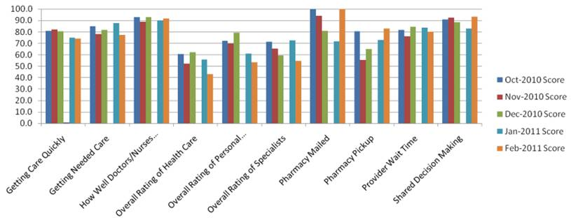

There is a glaring lack of corroboration between the Executive Staff of the Seattle VAMC and local Veteran Service Organizations. Turnover seems to be a concern as the whole executive staff has been on board less than six months.

Quality Manager
The Quality Manager Ensures that components of the quality management system and patient safety improvement program are integrated and that a systematic process is in place for monitoring the facility quality data. The Quality Manager also Serves as the quality consultant to the facility leadership, Quality Improvement (QI) or Performance Improvement (PI) teams, and employees.
Quality is measured through performance measures including SHEP, and polls that are a small sample but can lead to process review. Seattle is Now going to Press Ganey so that the data may be received quicker, and can be focused as small as individual providers. The facility also uses clinical measures, mortality rates and charts to measure performance.

One of the biggest challenges at Seattle VAMC is not a lack of data, but how the data is used. The sheer volume of data through SHEP is overwhelming. A new department was created to analyze the Quality Management. There is no central clearinghouse is how this department will take care of the data. The clearinghouse will be a uniform way to clear and pull the data, and compare to national data through various reports. There is an ongoing Partnership with Portland for analysis and data management. SHEP scores are used to drive customer satisfaction and comprehensive systems analysis. The Quality Management team is developing a training library compiled of materials received during training seminars. When a provider attends a training seminar the information received will be entered into an electronic database that employees will use to receive the same training without the cost to the facility.

Patient Safety Manager
The Patient Safety Manager Ensures that components of the Quality Management System and Patient Safety Improvement Program are integrated and Implements a coordinated patient safety improvement program that is based on guidance and tools from the National Center for Patient Safety (NCPS) and which meets the needs and priorities identified by the Facility Director. These include addressing important standards, requirements, and recommendations to improve patient safety.
The Seattle VAMC has a strong patient safety program that has been consistently recognized by VACO for excellence by receiving the Gold Cornerstone Award. All RCA’s are completed within the 45 day mandated period. During each morning report patient safety is the first agenda addressed by members of the Patient Safety committee that is chaired by the Associate Chief of Staff and Safety Director. The Seattle VAMC Culture is one of safety; People are more aware of safety and near misses. Given the blame free culture providers are more likely to report events or near misses.
Regardless of how exceptional the program is there is always room for improvement. Providers would like to see more opportunities for training and to attend national seminars.

System Redesign
The SRD manager seeks to find ways to balance patient care demand with available resources that provide that care and incorporates other organizational programs and leaders in improving the way we deliver our care.
An important aspect of system redesign is population. If the patient does not need to be admitted then the facility will find other ways to treat the patient. If a patient is wrongly admitted he/she is taking up valuable space. System Redesign is infrastructure redesign so the veteran patient is always in the center; however, the facility would like to change the name to patient of systems innovations.

Health Informatics
The Chief Information Officer (CIO) directs the Office of Information & Technology (OI&T) to deliver adaptable, secure and cost effective technology services to the Department of Veterans Affairs (VA) and acts as a steward for all VA's IT assets and resources. The CIO mission is to provide and protect information necessary to enable excellence through client and customer service.

Patient Satisfaction
VA Puget Sound has a dedicated position for Customer Satisfaction Manager which is a GS-12 position. The position supervises the 4 GS-11 patient’s advocates, serves as the patient centered care coordinator, and serves as the co-chair on the Customer Satisfaction Board. In reality, all staff at VA Puget Sound have customer service responsibilities as a collateral duty. Seattle defines patient satisfaction as Providing timely and quality care to all Veterans. Patient satisfaction is measured mainly through SHEP Surveys. Another method to measure patient satisfaction is post discharge phone calls. Calls are made to all patients who are discharged from an inpatient stay and then surveyed about the care that they had received; information from these calls are used to improve care. Providers also make rounds throughout the facility; checking on patients and speaking to veterans visiting the facility for appointments. By rounding the facility and visiting with Veterans providers and executive staff are able to ascertain the veterans perspective on their experience. Veterans do participate in some committees giving them a voice within facility leadership.
Patient Advocate
The Patient Advocate provides concern resolution, address compliments with service lines, provide customer satisfaction training, and make inpatient visits to new patients and provide concern resolution to inpatients. The Patient Advocate works as the veterans voice at the medical facility. If a veteran has a concern, he/she approaches the patient advocate who works collaboratively with the providers to settle the dispute in a non punitive fashion. All veteran concerns are entered into the PATS system so they may be tracked, and any consistencies are addressed in morning meetings.

PACT
The PACT coordinator oversees the implementation of PACT principles at all 9 Puget Sound Clinic sites and the Seattle VAMC. With the OIF/OEF population growing at an average rate of 8 percent per year it is imperative to enroll the veterans ASAP and assign them providers. Veterans complained of difficulties with the phone system so the facility hired nine operators to assist veterans who call for appointments. By hiring more operators the average wait time has been reduced to one minute; the facility is striving to reduce the wait time to 30 seconds.

